Chapter 2, Problem 57.

Find R_{eq} and I in the circuit of Fig. 2.121.
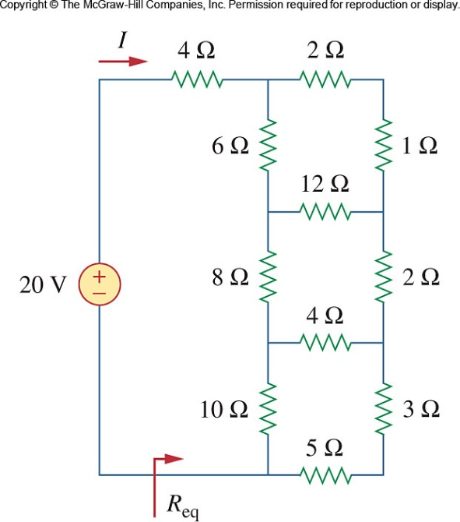

Figure 2.121
For Prob. 2.57.

